**3. FRONT VIEW**

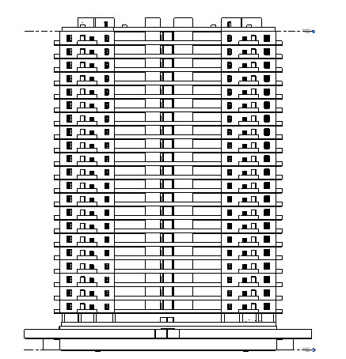

**SIDE VIEW**

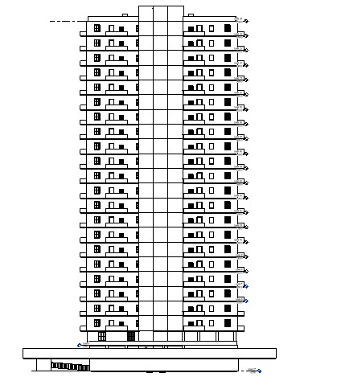

**ISOMETRIC VIEW**

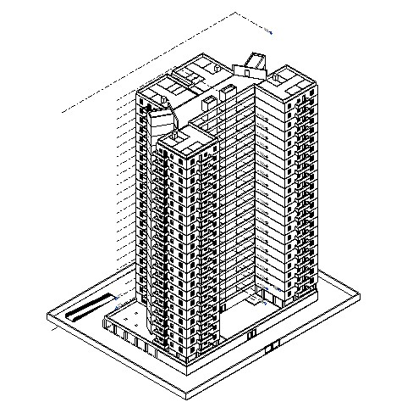

**4. FLOOR PLAN**

**Ground floor plan**

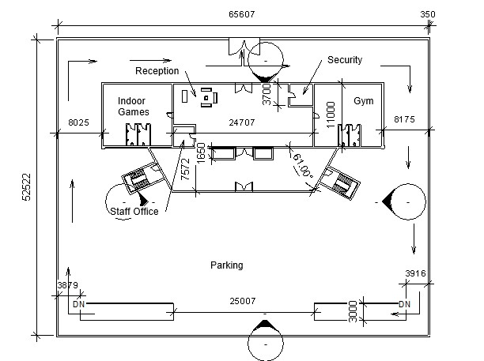

**Basement plan**

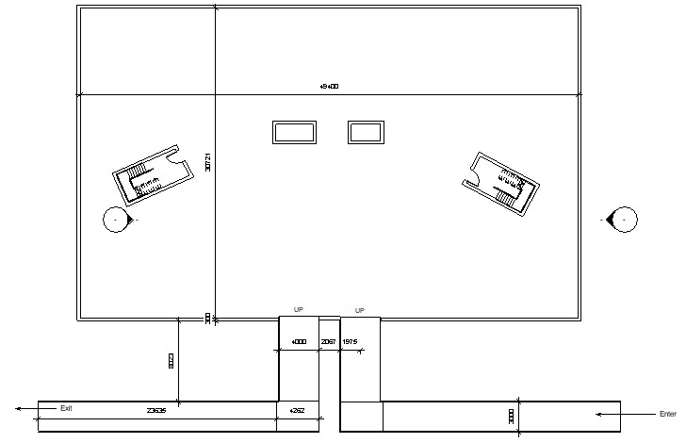

**First floor plan**

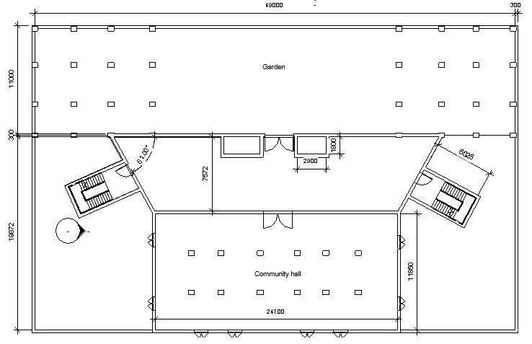

**Floor plan**

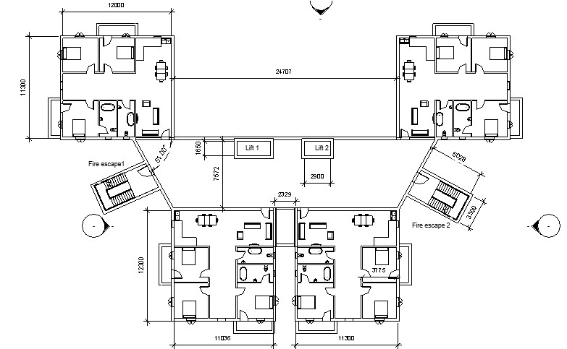

**Roof plan**

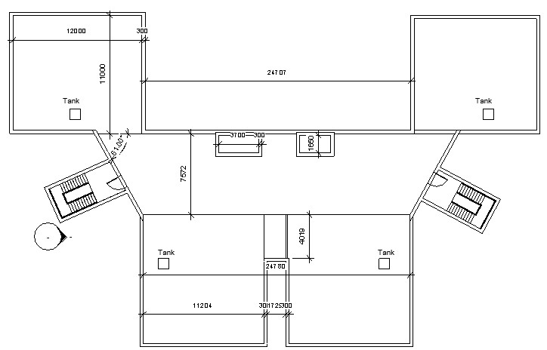

**5. Beam column layout**

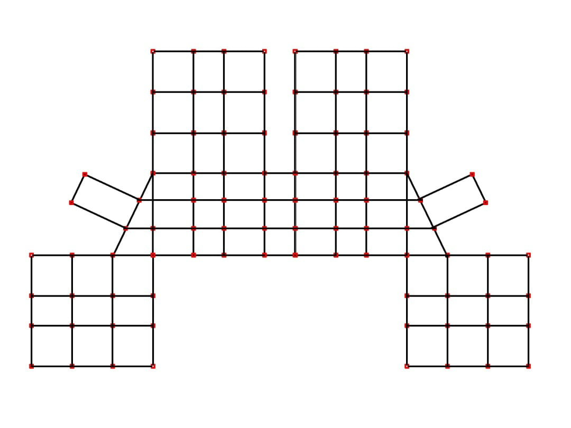

**Dead load**

|  |  |
| --- | --- |
| Dead Load | Value |
| Self-weight Factor | -1 |
| Slab | 3.75KN/m^2 |
| Exterior wall | 16.464KN/m |
| Interior wall | 11.76KN/m |
| Parapet wall | 6.1152KN/m |
| Floor finish | 1KN/m^2 |
| Roof finish | 0.5KN/m^2 |
| Water tank load | 22KN/m^2 |

**Live load**

|  |  |
| --- | --- |
| Live Load | Value(KN/m^2) |
| Bedroom | 2 |
| Toilet & Bathroom | 2 |
| Kitchen | 2 |
| Dining cum Living Room | 3 |
| Staircase | 3 |
| Common Space | 3 |
| Balcony | 3 |

**Wind load**

|  |  |  |
| --- | --- | --- |
| Wind Data | Value | Reference |
| Basic wind speed (vb) | 47 m/s | Figure 1, IS 875,part 3 |
| Wind Zone | 4 | Figure 1, IS 875,part 3 |
| Terrain category | 4 | IS 875,part 3, section 5.3.2.1 |

Design factors: -

|  |  |  |
| --- | --- | --- |
| Design Factors | Value | Reference |
| Risk Coefficient Factor, k1 | 1 | Table 1 IS 875 Part 3 |
| Terrain & Height Factor, k2 | Varies with height |  |
| Topography Factor, k3 | 1 | Clause 5.3.3.1 IS  875 Part3 |

|  |  |  |
| --- | --- | --- |
| Design wind parameters | Value | Reference |
| Design Wind Speed  Vz = Vb*k1*k2*k3 | 47k2 | Clause 5.3 IS 875 Part3 |
| Pz = 0.6(Vz) ^2 | 1325.4k2^2 | Clause 5.4 IS 875 Part3 |

Variation of Pz with height: -

|  |  |  |
| --- | --- | --- |
| Height m | k2 | Pz (kN/m2) |
| 10 | 0.8 | 0.848 |
| 15 | 0.8 | 0.848 |
| 20 | 0.8 | 0.848 |
| 30 | 0.97 | 1.247 |
| 50 | 1.1 | 1.604 |

**Earthquake load**

Design parameters for calculation of earthquake load

|  |  |
| --- | --- |
| Seismic Parameter | Value |
| Zone | 4 |
| zone factor | 0.24 |
| Importance factor | 1 |
| Response reduction factor | 5 |
| Structure Type | RC Frame Building |

**Plumbing**

Total Number of floors=21

Number of units on each floor = 4

Average number of members per family = 6

Total population= 21*4*6=504~500

Water required as per NBC 2016 = 150 Lpcd

Assuming FOS as 1.2

Total Water required= 150*500*1.2 = 90,000Lpd

Average 8hr pumping rate = 90000/8 = 11,250L

Average hourly demand= 90000/24 = 3750L

Considering Pumping hours from 6 am to 10 am and 2 pm to 6 pm

Storage capacity= max deficit + max surplus

= 11437.5+14250 = 25687.5L

Storage capacity as per table 16 SP35

Storage capacity= population *70L

= 35000

|  |  |  |  |  |  |  |  |
| --- | --- | --- | --- | --- | --- | --- | --- |
| Time From (h) | Time To (h) |  | Demand in the given period(L) | Cumulative Demand(L) | Pumping done in a given period(L) | Cumulative pumping(L) | Cumulative deficit or Surplus(L) |
| 0 | 4 | 0.8 | 3000 | 3000 | 0 | 0 | -3000 |
| 4 | 5 | 0.4 | 1500 | 4500 | 0 | 0 | -4500 |
| 5 | 6 | 0.8 | 3000 | 7500 | 0 | 0 | -7500 |
| 6 | 10 | 9 | 33750 | 41250 | 45000 | 45000 | 3750 |
| 10 | 12 | 2 | 7500 | 48750 | 0 | 45000 | -3750 |
| 12 | 13 | 0.6 | 2250 | 51000 | 0 | 45000 | -6000 |
| 13 | 14 | 2.25 | 8437.5 | 59437.5 | 0 | 45000 | -14437.5 |
| 14 | 17 | 2.1 | 7875 | 67312.5 | 33750 | 78750 | 11437.5 |
| 17 | 18 | 2.25 | 8437.5 | 75750 | 11250 | 90000 | 14250 |
| 18 | 20 | 1.8 | 6750 | 82500 | 0 | 90000 | 7500 |
| 20 | 22 | 1.4 | 5250 | 87750 | 0 | 90000 | 2250 |
| 22 | 23 | 0.4 | 1500 | 89250 | 0 | 90000 | 750 |
| 23 | 24 | 0.2 | 750 | 90000 | 0 | 90000 | 0 |

As per clause 5.4.2.3 of SP35

Storage capacity=Number of apartments x 270+(Total number of Bathrooms-Number of Apartments) x 180

= 84*270+(168-84)*180

=37800L

As per clause 5.4.2.3 of SP35

Maximum Storage capacity= 0.5*Daily water supply

= 0.5*90000

=45000

Storage of Overload tank=Max(25687.5, 35000,37800,45000)=45000L

Assuming 4 circular tanks of radius 1.2 m and height 2.5m

The sanitary fixtures in each apartment consist of the following:

a) 1 sink and 1 tap in the kitchen

b) 1 overhead flushing tank for the water closet and tap in each water closet room;

c) 2 showers, and 2 wash basins and taps; and

d) 1 mini geyser in each bathroom.

**Supply System**

In the downtake supply or downfeed distribution, the supply from the street main is drawn into a ground level storage tank wherefrom the supply is again pumped to an overhead storage tank and then the supply is drawn by gravity.

**Sewage system Design**

Two Pipe System: -

* In this system of plumbing, the soil and the waste pipes are distinct and separate, the soil pipes being connected to the building drain directly, and the waste pipes connected to the building drain through a trapped gulley.
* All traps of soil appliances are completely ventilated through a separate ventilating pipe. Likewise, traps of all waste appliances are also completely ventilated through a separate ventilating pipe. Thus, it contains one soil pipe, one waste pipe and two ventilating pipes.
* The vent pipe is installed to provide a flow of air to or from a drainage system or to provide circulation of air within such system to provide protect trap seals from siphonage and backflow. The system consists of one main ventilating pipe (MVP) to which branch vent pipes (BVP) of each storey are connected. The MVP provides a safe outlet for the foul gases in the drain or sewer into the atmosphere.

A Two-pipe system will be provided in the residential blocks for disposal of sewage where soil pipes are connected to the building drain direct and the waste pipes are connected to the building –drain using a rapped gulley.

A Main ventilation pipe (MVP) is provided for the main waste pipes (MWP) and the main soil pipe (MSP).

1. Waste Appliances (Internal diameters) (Table54ofSP 35)

|  |  |
| --- | --- |
| **Waste Appliances** | **Internal Diameter** |
| Wash Basin | 30mm |
| Bathrooms | 40mm |
| Water Closet | 50mm |

2. Horizontal branches for each floor(diameters) (Table 52 of SP35)

|  |  |  |
| --- | --- | --- |
| **Floor** | **MWP** | **MSP** |
| All Floors | 100mm | 100mm |

MWP and MSP columns indicate the diameter of the horizontal branches joining MWP and MSP respectively.

MWP and MSP (Table 53 of SP 35)

The diameter provided for all the MWP and MSP is 150mm.

MVP (Main ventilation pipe) (Clause 6.7.5.3ofSP 35)

The diameter provided for the MVP is 50mm.

We have the total water demand calculated in the previous section 90,000L/day

• Now assume 90% of total consumption to reach the sewer

• Here, peak factor=3(since population <20,000)

• ➢Total storage= 90,000*0.9*3 L/day

• = 2812.5 cm^3/s

• Now using Mannings’ formula Q=AR2/3√s/n

• Take slope of main sewer pipe= 1/1000

• Mannings’ coefficient= 0.012

• ➢2812.5 =πd2/4*(d/4)2/3*√(1/1000)*(1/0.012)

• => d= 21.15

• => Provide a 220 mm diameter pipe for the sewer pipe connecting the sewage from all the flats to the municipal sewage system.